Indianapolis  Kokomo  Avon  Fishers  Terre Haute
1.800.888.HAND

EXTENSOR TENDON REPAIRS (ZONES IV–V)
EARLY ACTIVE – RELATIVE MOTION EXTENSION (RME) PROGRAM
Initial 4 – 6 Weeks Postop

Introduction
The anatomy of the extensor tendons (on the back of your hand and fingers) is complex. When one or more of the tendons have been injured and repaired, it is important to protect your repairs and permit limited tendon gliding. This will prevent the tendons from becoming adherent to the overlying skin and underlying bone. This can be achieved with a carefully crafted and customized therapy program specific to you.

Excellent outcomes can be achieved by carefully following the therapy guidelines outlined below.

- You have been fitted with a custom-fabricated orthosis to protect your tendon repair(s). The orthosis must be worn at all times to avoid the risk of tension on your repair. Tension on your repair could result in a tendon rupture or “stretching out the repair”.

- Wear the small orthosis as shown below. A wrist orthosis may be added at the discretion of your surgeon and/or therapist.
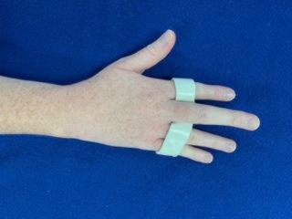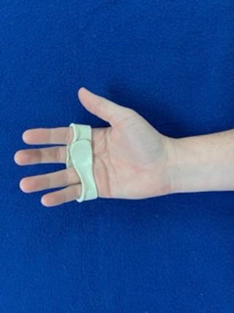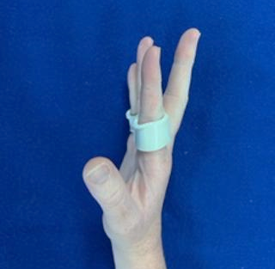
Perform the following exercises slowly __________ repetitions, ____________ times a day.

- Bend and straighten your fingers as shown below.

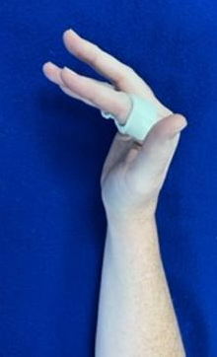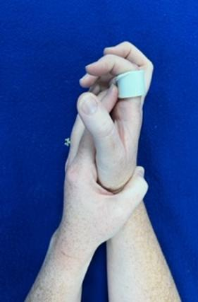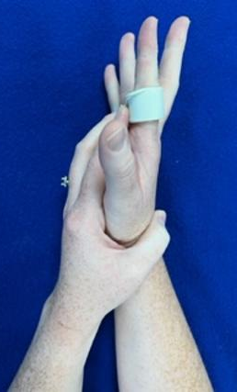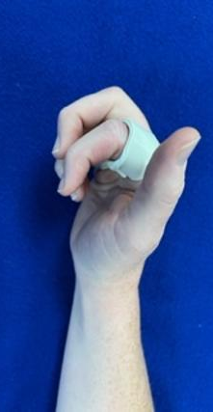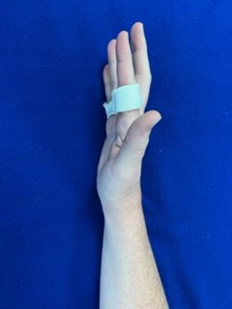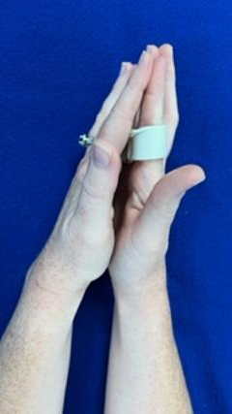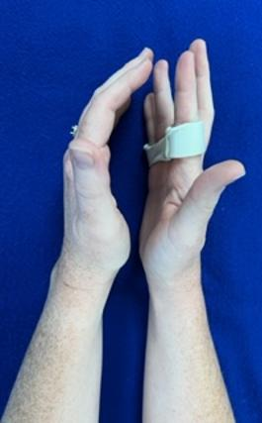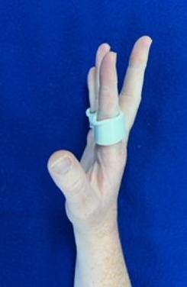

- At 2-wks postop, bend and straighten your wrist as shown below, while wearing your finger orthosis.
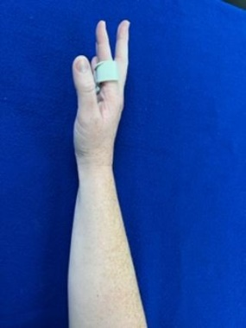
- Relax your fingers while bending your wrist down. (B) Bend your wrist back & make a light, full fist.
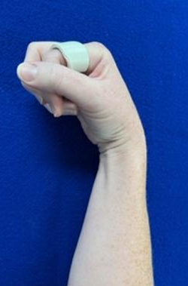
- At 3 wk postop, begin gentle active wrist and finger flexion (bending). (D) Straighten your fingers.
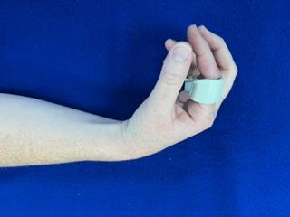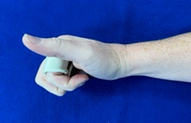
- (B) (C) (D)

EXTENSOR TENDON REPAIRS (ZONES IV–V)
EARLY ACTIVE – RELATIVE MOTION EXTENSION (RME) PROGRAM
Initial 4 – 6 Weeks Postop (continued)

Home Program
- ________________________________________________________________________________________________________
- ________________________________________________________________________________________________________
Patient Education

- Control of Swelling
- Keep your hand elevated above your heart the initial 2 weeks following surgery to limit swelling and minimize scar tissue. Limiting scar tissue is of great importance. This will limit the risk of the tendon(s) becoming adherent.
- While lying in bed, with your arm overhead, create the letters of the alphabet with your arm. This will help limit the swelling too. Perform this exercise in the morning and at night for the first month.
- Wound Healing
- Until instructed by your therapist, please keep your hand dry (e.g. wear a plastic bag over your arm while showering the initial month following surgery).
- To wash your hand, either leave the orthosis in place and dry once you are done or remove and place a small/short pencil or tongue depressor in the place of the orthosis to wash your hand. The finger must remain protected in the straight position.
- Scar Massage with Lotion
- After your stitches are removed (10-14 days postop typically), and your wounds have completely healed (typically 3-5 days later), you may begin gentle scar massage with lotion along the area of your healed incision. Please perform gentle scar massage 3 times a day for ~3 minutes. This will help to decrease pain and remodel the scar. (Note: If the incision is not completely healed, you may begin scar massage 3-5 days after the incision is completely healed.)
- Wearing the Orthosis
- Wear your finger orthosis at all times. Your therapist and/or surgeon will advise you when you can begin gradually reducing the wearing time in the orthosis.
- If you have been fitted with a wrist orthosis, be sure to wear the orthosis as indicated by your therapist or surgeon.
- Please understand, if you remove your orthosis and use your hand for any reason, you could risk rupture of your tendon repair(s).
- Using your Hand
- You may use your hand, with the orthosis on properly, to perform light functional activities.
- Avoid a tight grasp or tight grasp against any resistance the first month postop.
- Limit bilateral lifting (with a light grasp only) to less than 10 pounds the first month.
- Bilateral grasping can be steadily increased as determined by the surgeon and/or therapist. By two months postop the weighted lifting can steadily be increased to 20 pounds or more.
- Avoid all sports requiring upper extremity involvement, until discussed and approved by the surgeon and/or therapist. Typically, this will be between two and three months postop.
- Check with your therapist on special tasks you want to perform with your hand. Many tasks can be performed early on. It is simply important to discuss those tasks, to avoid the risk of an accidental injury.
- The program was researched, developed and subsequently published in the Journal of Hand Therapy (JHT) in 2005 by lead author Julianne Howell, PT, MS, CHT, along with WH Merritt, MD, and SJ Robinson, PT.

- Other Comments & Recommendations:

- _________________________________________________________________________________________

